**SOFTWARE QUALITY IN SOFTWARE**

Adrian Alex Jacobs

3850269

3850269@myuwc.ac.za

This definition of quality refers to the use of effective software processes to produce a useful product that serves the needs of those who create it and those who use it. The quality of software is determined by both the design (quality of design) and its conformance to that design (quality of conformance). A piece of software's 'fit for purpose' is often described as its functionality. [1]

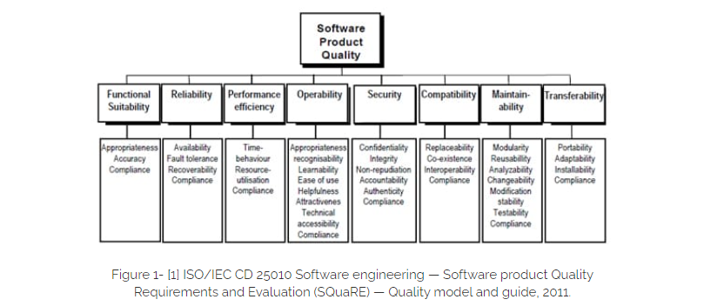

**CHARACTERISTICS OF SOFTWARE ENGINEERING**

1. Functional suitability
2. Reliability
3. Operability
4. Performance efficiency
5. Security
6. Compatibility
7. Maintainability
8. Transferability

Additionally, the standard defines a quality-in-use model composed of five characteristics:

1. Effectiveness
2. Efficiency
3. Satisfaction
4. Safety
5. Usability [2]

**ASPECTS OF SOFTWARE QUALITY**

**Reliability**: Consistent behaviour makes software reliable. It should be possible to predict and repeat the functionality of a program. It is desirable for errors to occur rarely or not at all. The handling of errors should be graceful and proactive when they do occur. Whether or not software will work correctly should never be a concern for users. [3]

**Understandability**: It must be possible to understand the structure, the components, and the source code. It is essential that they be clear. Well-organized documents are essential. Developers expect them to behave in a certain way. Whenever developers encounter confusion in the code, it shows that the code is not understandable. Source code that is high in quality is always simple and obvious to read. [3]

**Modifiability**: Additions or changes to a system's behaviour should be easy. Changing the behaviour of a flexible system requires very few lines of code. Applications should have plugin points that allow them to be used with different contextual elements in order to achieve the expected dimensions of change. It is absolutely unacceptable to keep a tight grip on an element that is expected to change. [3]

**Usability**: A software product must be easy to use and simple to understand. It is important to present the most common use cases in the most obvious and clear way possible. It should not be necessary to configure software excessively. You should make your software feel empowered to your users. In order to discover the core functionality of an application, users should not have to search the internet. [3]

**Testability**: It is essential that software can be verified for functionality. A simple testing process is required for the software. It is important that each business use case can be directly tested. It is essential to have clear verification metrics. A comprehensive automated test suite will be included with highly testable software. [3]

**Portability**: Different environments and contexts can be used with portable software. The software is highly reusable. The deployment context, operating systems, and hardware for portable software are not dependent on each other. Across projects and domains, extremely portable software can be reused. [3]

**Efficiency**: Physical resources are used as sparingly as possible by efficient software. It is very fast. Memory usage is low. CPU cycles are used sparingly. The battery life of the device is short. There are few calls to external services made by it. By minimizing database calls, it saves time and energy. Software that is efficient uses as few resources as possible in order to accomplish as much as possible. [3]

**WHY IS EFFECIENCY DESIRABLE TO HAVE IT IMPLEMENTED IN MODERN APPLICATIONS/SYSTEMS/APPS**

Increasing the efficiency of software development leads to shorter product life cycle times, shorter time to market, and ultimately better results. The efficiency of the software development process can be measured using a variety of metrics. [5]

**HOW EFFICIENCY AND PORTABILITY IS USED IN WHATSAPP BUSINESS**

The popularity of WhatsApp can be attributed to the fact that it is free for consumers. This means that it can be used instead of SMS and phone calls, which are both paid services. You can stay in touch with loved ones and friends abroad thanks to this service. The app is intuitive to use and only requires a phone number to get started. [4]

It uses very little system resources to receive and send messages. The app is also very portable as it can be accessed from almost any device, including mobiles/smartphones, laptops and desktops.

**References**

[1] XBOSOFT. Definition of Software Quality. [https://xbosoft.com/software-qa-consulting-services/definition-software-quality/#:~:text=“In%20the%20context%20of%20software,of%20a%20piece%20of%20software](https://xbosoft.com/software-qa-consulting-services/definition-software-quality/#:~:text=).”

[2] ASQ. LEARN ABOUT QUALITY. SOFTWARE QUALITY. <https://asq.org/quality-resources/software-quality>

[3] SILAS REINAGEL. The Seven Aspects of Software Quality. (Nov 15, 2016) <https://www.silasreinagel.com/blog/2016/11/15/the-seven-aspects-of-software-quality/>

[4] Dimira Teneva. sendinblue. 15 Benefits of Using WhatsApp for Business. <https://www.sendinblue.com/blog/benefits-whatsapp-business/>

[5]  [Applaudo Studios. How to measure software development efficiency. (2021-08-17) https://applaudostudios.com/blog/posts/how-to-measure-software-development-efficiency](%20Applaudo%20Studios.%20%20How%20to%20measure%20software%20development%20efficiency.%20(2021-08-17)%20%20%20%20https://applaudostudios.com/blog/posts/how-to-measure-software-development-efficiency)